HANDLING AND INSTALLATION GUIDE

Site Preparation – Excavation, Foundation and Bedding

Before the pit arrives on site, the site should be prepared accordingly by excavating to provide clearance from all external faces and to ensure that there is enough room to work around the outside of the pit. Additionally, the appropriate foundation must also be prepared. Pits must be installed on a stable, well-compacted foundation to avoid future settlement (subsidence).

Should any softening or loosening occur following excavation, the soft/loose materials must be removed and replaced with a suitable material e.g. single size coarse aggregate to the requirements of the relevant authority. The compacted depth of replacement material should be uniform and sufficient to ensure that the minimum specified bearing capacity is achieved.

Once the foundation has been stabilized, the bedding material of sand or gravel should be placed onto the foundation to a uniform depth. The bedding is designed to provide uniform support across the whole underside of the pit.
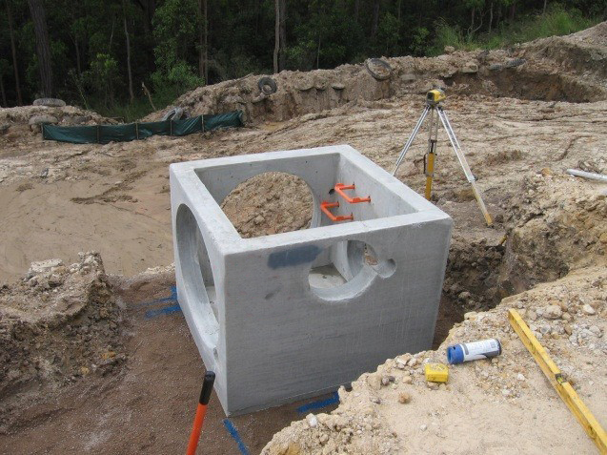
Pit positioned on leveled bedding material

Bedding material and compaction should comply with the project specific drawings and the relevant authority specifications. It is recommended to consult with the site engineer for bedding material and compaction requirements; especially where unusual ground conditions may occur.

General acceptance is an approved bedding material compacted to a thickness of not less than 80 mm on an earth foundation or 150 mm on a rock foundation. The invert level of the pipe and the base thickness of the pit have to be considered when preparing the bedding (placing, leveling and compacting).
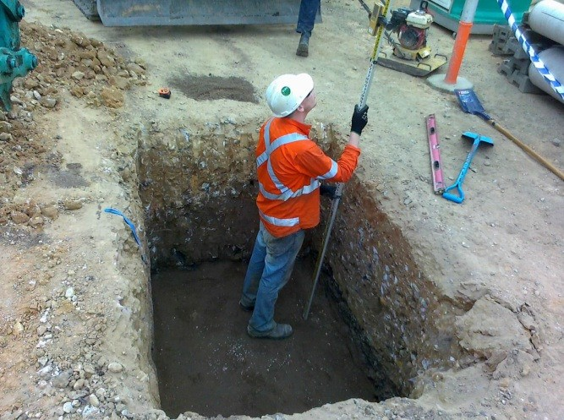
Checking the base

Lifting

All FCP precast units are supplied with cast-in lifting points (either lifting holes or proprietary lifting anchors) to enable safe handling. To prevent stress and possible concrete cracking, all units must be handled using only the designated and marked lifting points and associated lifting pins or clutches as required.

When using FCP lifting pins always ensure that the FCP lifting procedure is followed for correct installation of the pins into the lifting holes. When clutches are used always ensure the clutch matches the lifting anchor e.g. use a 1.3 tonne clutch only on a 1.3 tonne anchor.

In lieu of lifting clutches approved side lifters can be used. All lifting equipment is to be provided by the contractor and is readily available from FCP.
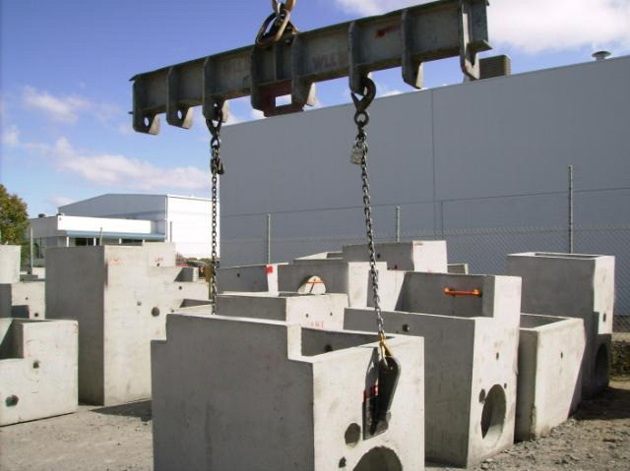
Lifting with spreader bar

Pit installation

While the relevant authority specifications should be consulted and followed our pits are typically installed as follows:
- Check that the foundation and bedding material have not been disturbed.

- Lift the pit into position using lifting pins or clutches as necessary. It is the contractor’s responsibility to ensure safe lifting practices are followed. Ensure that the pit is oriented correctly for the pipes to be connected to the pit.

- Pipe jointing to pits requires the following steps:
  - Place the pipe into the penetration, cutting the pipe so that it is flush with the internal wall of the pit.

  - Seal the wall with an approved cement mix. It may be necessary to render around the pipe on the inside of the pit in order to achieve a quality flush finish with the pit wall. Other grouting materials might be required to suit harsh soil conditions, such grout can be specified by the site engineer, site supervisor or relevant authority.

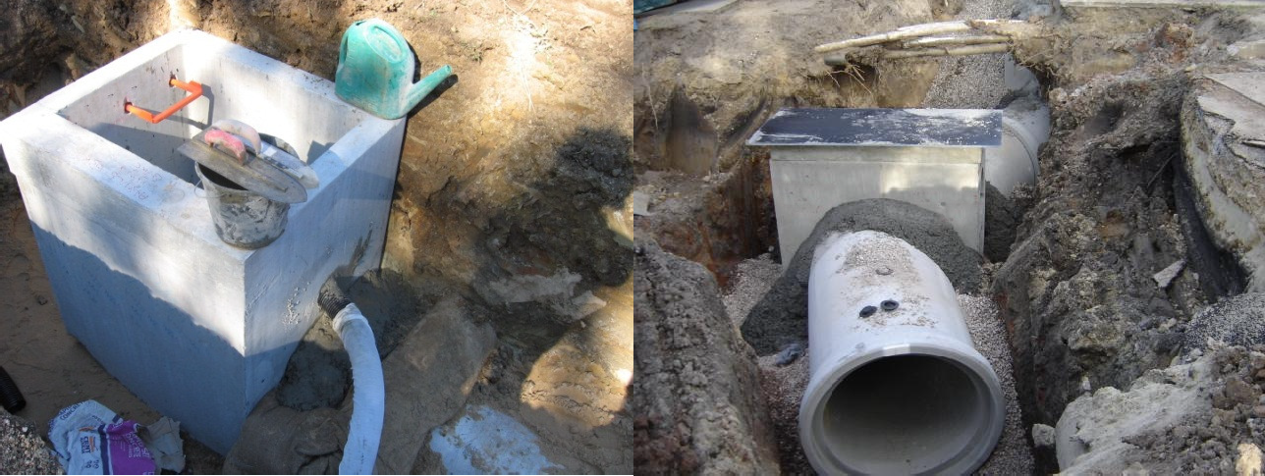
External Joints
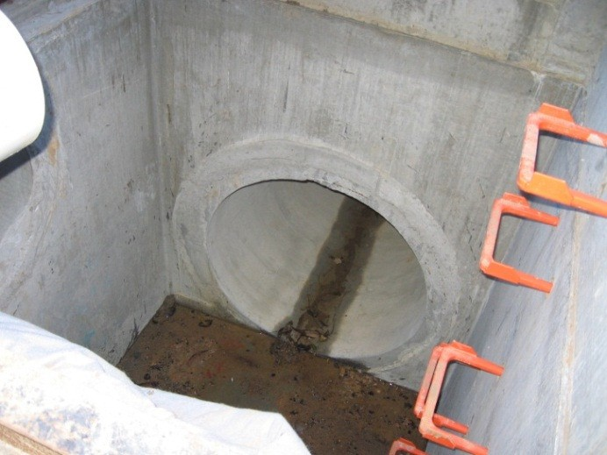
Internal Joint

- FCP provide step irons installed in pits where required by the relevant authority. When working inside pits always ensure that the step irons are secure before using. The steps that are installed in our pits are only designed to be installed once. Should the removal of steps be required to facilitate any works inside the pits it is the contractor’s responsibility to ensure that the steps are secured in place chemically when re-installed.

Backfilling

When the pits and pipes have been laid and sealed, backfilling can occur. The material used for backfilling the pit is typically the same as the material used for backfilling the pipeline however the relevant project or authority specifications should be followed.
Evenly place and uniformly compact the material ensuring that components and joints are not disturbed or displaced.
Backfill with the aim of minimal or no subsidence after completion of the works. Compaction should be to the satisfaction of the site supervisor or the relevant authority.
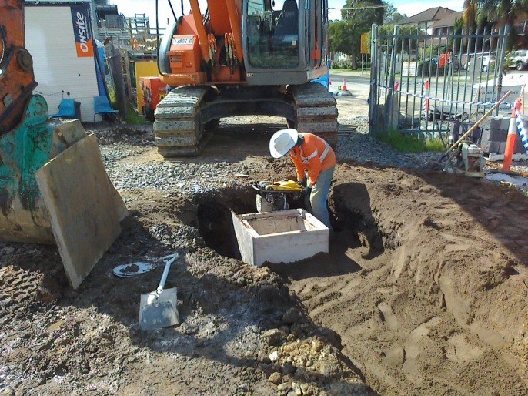
Compaction of backfill around pit

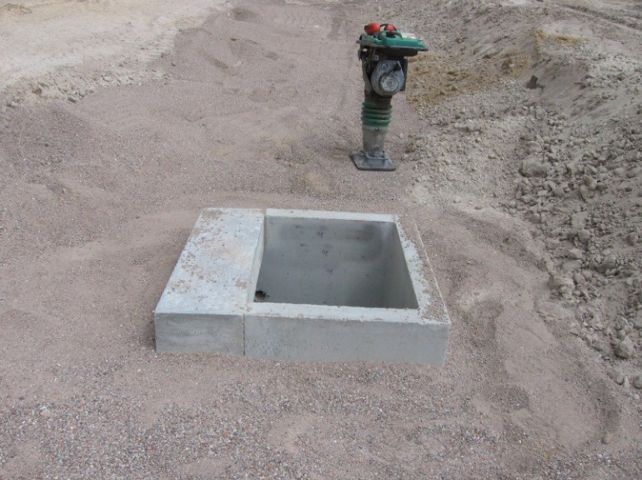
Ensure even placed material

