Where is it Going?
- The best place to have a below ground tank is close to the source of the contaminated water.
- The second-best place is close to the source and with ease of servicing and maintenance in mind.
- The type of lid must be suitable for the traffic, i.e., a light duty cover is not suitable for a truck but is suitable for foot traffic.
- The worst place is far from the source (refer pump stations), up hill (refer Leidenfrost Effect) or with the wrong type of lid (refer waver).
Excavating and Preparing the Hole
- Identify where the unit is going, i.e., don’t dig a hole on the wrong property.
- Call dial before you dig and confirm that there are no services in the area.
- The excavation should be at least 300mm wider than the size of the unit and the depth should be slightly deeper than the unit to allow for some packing sand or crushed rock, i.e., a firm level base. Also remember to allow for the lid.
- Verify which end is the inlet and which is the outlet and that the pipes line up – you may require an extension or riser depending on the invert of the pipework.
- Remember to barricade the excavation if it is being left open.
Placing the Unit & Finishing the Job
- Prior to the delivery of the tank, you should ensure that there are no obstacles, no over-head power lines, clear access is required.
- The crane truck which delivers our concrete tanks should be able to reverse up to the excavation. The trucks have rear mounted cranes.
- After the unit has been placed the excavation should be backfilled with either sand or crushed rock or any other suitable fill and compacted.
- Then pay FCP whilst you wait for the builder to pay.

Regards,
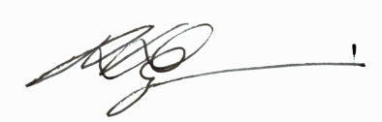
Nicholas Zigouras
General Manager
Frankston Concrete Products

Waiver: The installation of a below ground tank should be installed by a suitably qualified person, aware of the regulations and requirements of the Local Water Authority prior to installation.

