GENERAL
All Reinforced Concrete Pipe (RCP) should be installed by a licenced practitioner and in accordance with AS3500.3:2021 Plumbing & Drainage Stormwater Drainage and AS3725:2007 Design for Installation of Buried Concrete Pipes.
Specific installation requirements may vary based on factors such as pipe size, location, soil conditions, and project specifications.
STEP
- Preparation:
Review the project specifications and plans to determine the required pipe sizes, lengths, and other specifications.
Ensure that the excavation site is properly prepared, including trench dimensions and compaction requirements.
- Excavation:
Excavate the trench to the required dimensions, ensuring proper slope, depth, and alignment.
Remove any loose or unsuitable material from the trench bottom and sides.
Verify that the trench is properly compacted and levelled.
- Bedding:
Place a suitable bedding material at the bottom of the trench. The bedding material should be well-compacted and provide support to the pipe.
The type and thickness of the bedding material should be determined based on the pipe size, material, and loading conditions.
- Pipe Installation:
Carefully lower the concrete pipes into the trench, ensuring proper alignment and orientation using the two 1.3t lifting foot anchors cast into the pipe. See Figure 1
Install the pipes with the 14mm rubber D ring provided. See Figure 2.
Ensure that the joints are properly sealed and aligned to prevent leakage.

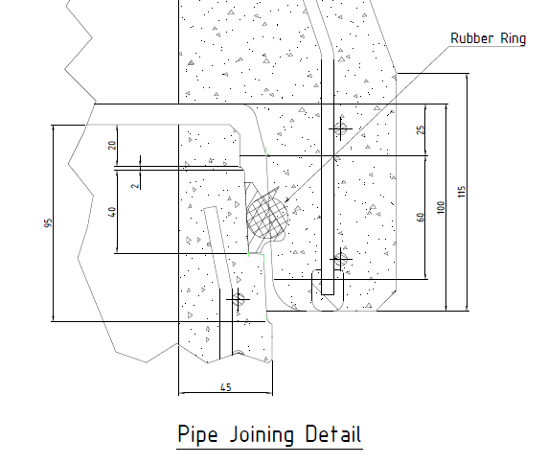
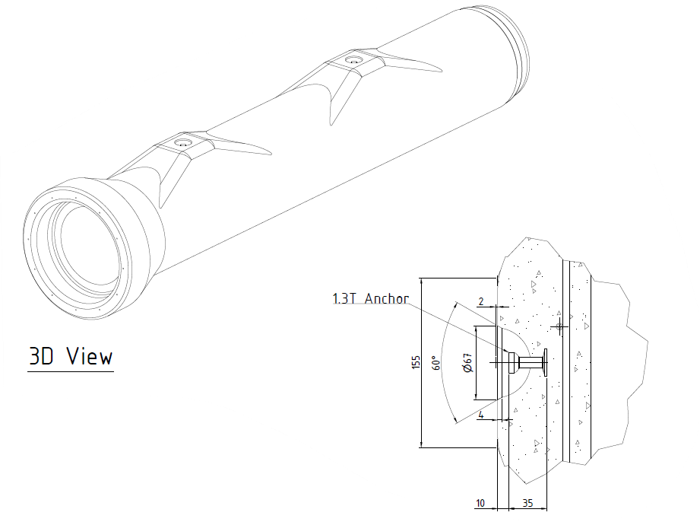
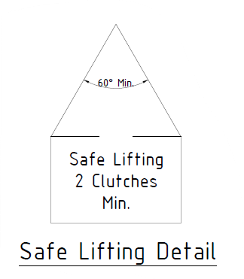
Figure 1
- Backfilling:
Gradually backfill the trench using approved backfill materials. The backfill material should be placed in thin layers and properly compacted.
The compaction should be done uniformly around the pipe to avoid excessive stress or deformation.
Figure 2
The backfill material should be free from large stones, rocks, or other sharp objects that could damage the pipe.
- Surface Restoration:
Once the pipe installation and backfilling are complete, restore the surface to its original condition or as specified in the project plans.

